Unit 2 Study Guide Name:________________________________________ Block:________

Circular Flow

- What is the product market?

- What is the resource/factor market?

- What types of transactions occur in the product market? Give a specific example.

- What types of transactions occur in the resource market? Give a specific example.

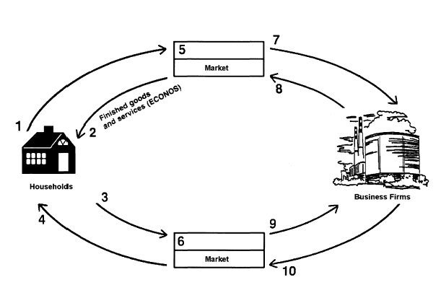
- Label the circular flow diagram below:

Law of Demand

- What is the law of demand?

- What are the two things required to be part of the demand for a particular good or service?

- What kind of relationship does the law of demand illustrate?

- What causes a movement along the demand curve?

- What five things can cause a shift of the demand curve to the left or right? (list and give explanation)
Important: a shift of the demand curve means a change in demand at every price!!
1.
2.
3.
4.
5.

- What does it mean when the demand for a product is inelastic?

- What would cause a demand curve to move to the left? (give specific example - #10 will help you)

- What would cause a demand curve to move to the right? (give specific example - #10 will help you)

- What is elasticity of demand?

- What is an inelastic good? (give definition and 2 examples)

- What is an elastic good? (give definition and 2 examples)

- What four factors influence whether a good is inelastic or elastic? (pg. 91-94)

Law of Supply

- What is the law of supply?

- What kind of relationship does the law of supply illustrate?

- List five things that could cause a shift (to the left or right) of the supply curve.
1.
2.
3.
4.
5.

- What would cause the supply curve to shift to the left? (question #20 will help you)

- What would cause the supply curve to shift to the right? (question #20 will help you)

- What is elasticity of supply?

- Describe a good or service that would have an inelastic supply.

- Describe a good or service that would have an elastic supply.

- What is the one thing that has the largest influence on whether or not a good or service is price elastic or inelastic?

Combining Supply & Demand – Equilibrium Price & Quantity

- What is equilibrium?

- Draw a supply & demand graph that shows the location of the equilibrium, equilibrium price, and equilibrium quantity.

- What is a price floor?

- What is minimum wage? Is it a price floor or price ceiling?

- What is a price ceiling?

- What is rent control? Is it a price floor or price ceiling?

- Why does rent control cause a negative incentive for developers to create new apartments or maintain existing apartments?

- What is a shortage/excess demand?

- What is a surplus/excess supply?

- Draw a supply and demand graph that illustrates the location of a surplus and shortage.

- Match the following scenarios with the appropriate graph (A, B, C, or D). All questions are dealing with PIZZA.
  - The price of mozzarella cheese, an ingredient in pizza, rises. ____
  - The population of the U.S. has declined by 5%. _____
  - Sub sandwiches, a substitute for pizza, have decreased in price by $1.50. ____
  - The number of pizzerias in Athens has risen. _____
  - The government starts a new tax on the pizza industry. ______
  - Pizza is found to cause severe weight gain. _____
