Name: _________________________________________________ Block: ______
UNDERSTANDING CIRCULAR FLOW
SSEMI1 The student will describe how households, businesses, and governments are interdependent and interact through flows of goods, services, and money.
a. Illustrate by means of a circular flow diagram, the product market; the resource (factor) market; the real flow of goods and services between and among businesses, households, and government; and the flow of money.
b. Explain the role of money as a medium of exchange and how it facilitates exchange.

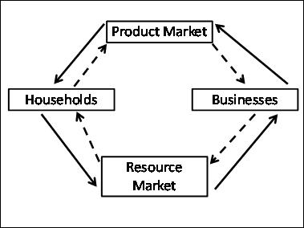

- What is a firm?

- Describe how Households and Businesses are interdependent in the resource market.

- Describe how Households and Businesses are interdependent in the product market.

- Which lines represent the flow of money through the economy?

- Give a real life example of an exchange that would take place in the product market.

- Give a real life example of an exchange that would take place in the resource market.

- How does money facilitate the exchanges taking place in the circular flow diagram?

